Comparison of Vector RAG and Vector-less RAG

- Introduction
RAG is a technique that improves the performance of LLMs by retrieving relevant information from a dataset and providing it as context before generating an answer.

Two approaches:
- Vector based RAG
- Vector less RAG

- Vector RAG
Vector RAG is a more advanced and widely used approach. It uses embeddings to represent text in numerical form so that semantic similarity can be calculated.

How it works:
- The PDF document is loaded and split into smaller chunks.
- Each chunk is converted into a vector using an embedding model.
- These vectors are stored in a vector database (ChromaDB).
- When a user asks a question, the query is also converted into a vector.
- The system retrieves the most similar chunks based on semantic similarity.
- These chunks are passed to the LLM, which generates the final answer.

Flow:

PDF → Chunking → Embeddings → Vector DB → Retrieval → LLM → Answer

- Vectorless RAG
Vector-less RAG is a simpler approach that does not use embeddings or vector databases.

How it works:
- The PDF is loaded and split into chunks, similar to vector RAG.
- Instead of converting to vectors, the system searches for chunks using keyword matching.
- It selects chunks that contain similar words to the query.
- These chunks are sent to the LLM to generate the answer.

Flow:

PDF → Chunking → Keyword Search → LLM → Answer
- Integration with LLM
In both approaches, the LLM (Groq LLaMA model) plays the same role.
- The LLM does not directly read the entire document.
- It only receives a few selected chunks as context.
- Based on this context, it generates a response.

Flow comparison:
Vector RAG:
User Query → Semantic Search → Relevant Chunks → LLM → Answer

Vector-less RAG:
User Query → Keyword Search → Relevant Chunks → LLM → Answer

- Comparison

Feature | Vector RAG | Vector-less RAG
Retrieval Method | Semantic (Embeddings) | Keyword Matching
Accuracy | High | Moderate / Low
Understanding | Context-aware | Exact word matching
Speed | Moderate | Fast
Complexity | Higher (needs embeddings + DB) | Simple
Setup | Requires vector database | No database needed
Scalability | Suitable for large datasets | Limited scalability
Flexibility | Handles synonyms and paraphrasing | Fails with different wording

- Results
After implementing both approaches and testing them on the same PDF document, the following observations were made:
- The vector RAG system produced answers with around 75–80% accuracy.
- It was able to understand the meaning of the question even when the wording was different from the document.
- The vector-less RAG system showed retrieval issues, especially when exact keywords were not present.
- In some cases, it failed to retrieve relevant chunks, which affected the final answer.
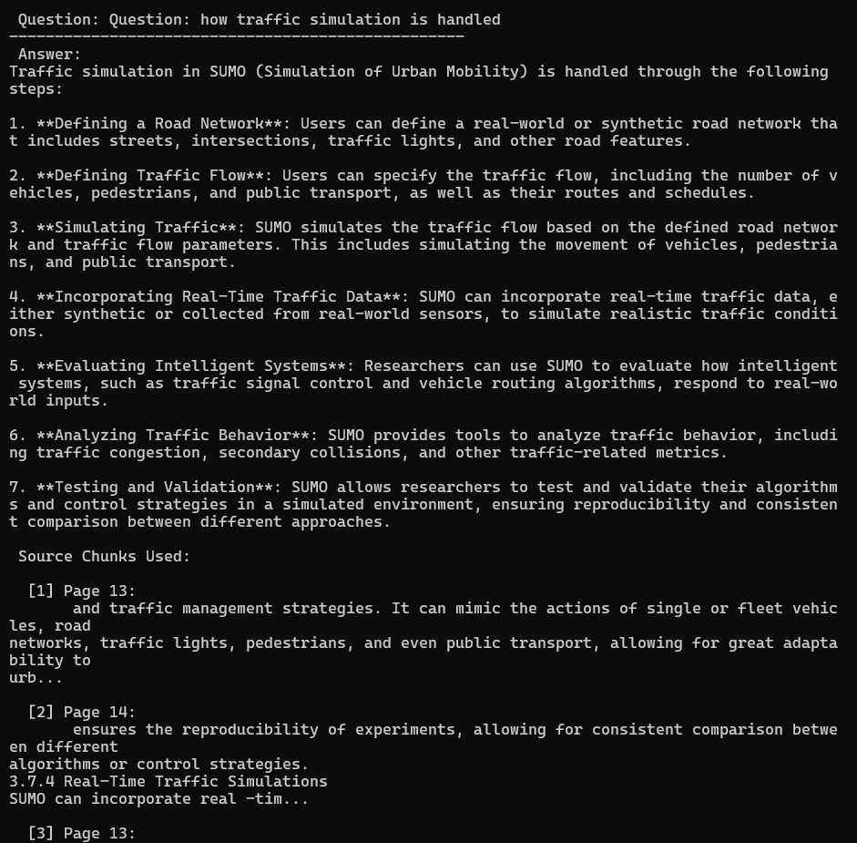
Vector based RAG output:

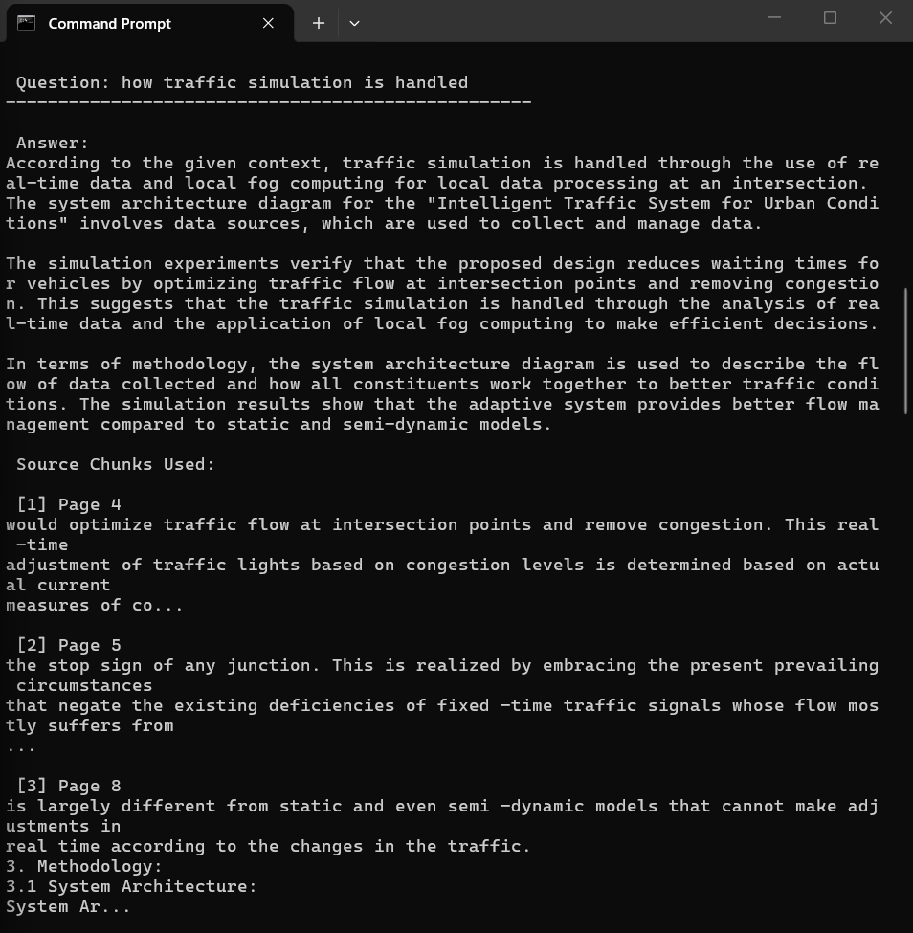
Vector less RAG output:

- Conclusion
From this comparison, it is evident that vector RAG performs better than vector-less RAG in terms of accuracy and reliability. The use of embeddings allows the system to understand context and meaning rather than relying only on exact words.

On the other hand, vector-less RAG is simpler and faster but lacks the ability to handle real-world queries effectively.

Therefore, for practical applications and larger datasets, vector RAG is the preferred approach.

